Science
Modeling and Visualization
Fourth – Fifth Grade Levels

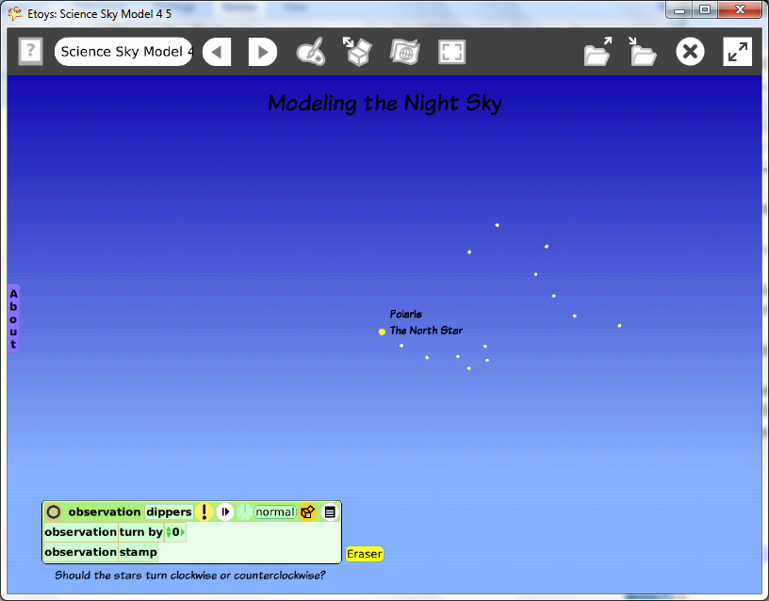

Introduction: | This lesson introduces using the computer to visualize the apparent clockwise rotation of the Earth by modeling the motion of two familiar asterisms: the Big Dipper and the Little Dipper. These asterisms can be found the constellations Ursa Major and Ursa Minor. Polaris, the North Star is in the Little Dipper. The example is a project of the two asterisms that were drawn as part of the K-1 Technology Passport. Students may redraw their examples or use the ones they did when they were younger. The technology makes it easy to try many ideas.
Topic: | Students write a script to make their drawing turn on the computer screen, change the center of rotation and leave a trail that will look very similar to time lapse photographs of the night sky.
Subject: | Science
Time: | Lesson 1 Two labs
Description: | Students will use Etoys scripts to experiment with virtual representations of objects they are studying in science. Modeling allows us to experiment with things too large, too small, too expensive or too alive. The lesson introduces a vocabulary of words common in science, mathematics, and everyday experience.
Vocabulary: | asterism, Little Dipper, Big Dipper, constellation, Ursa Major, Ursa Minor, Polaris, center of rotation, x- y, axis, y-axis, clockwise, counter clockwise, apparent, actual
Evaluation Criteria: | Draws the two asterisms: Big Dipper and Little Dipper in proportional relationship to each other on the screen  Knows the difference between an asterism and a constellation  Knows Ursa Major and Ursa Minor are constellations  Marks the location of Polaris in the Little Dipper  Writes a script that turns the asterisms on the screen  Can find the center of rotation of the two asterisms  Can move the center of rotation to Polaris  Can compare the result of adding a ‘stamp’ tile to the turn script and time lapse photography of the night sky  Experiments independently and applies basic knowledge and common sense  Records results and states conclusions
Teacher Information:  Etoys Quick Guides: Click the question mark in  Etoys to open the set of tutorials about basic tools and techniques. | Use Etoys Quick Guides if the lesson mentions unfamiliar tools or techniques. Give students time to read them too.  Etoys Quick Guides: Click the question mark in  Etoys to open the set of tutorials about basic tools and techniques.
Goals: | Students use Etoys scripts to make an object move on the screen and explore modeling the apparent motion of the night sky.  Students explore applications of positive and negative numbers.
Lesson 1:  Two labs  Supplies: Paint Tools  Halo Handles: Viewer  Supplies: Text  Script Tiles: Turn by  Script Tiles: Stamp  Script Tile: Pen Use  Navigator Bar: Keep Find Projects | Students and use a sky map to identify the Little Dipper and the Big Dipper. They can find and label Polaris, the North Star.  Students draw these two asterisms with one paint tool.  Move the center of rotation of the drawing so that it is exactly on Polaris.  Type the name Polaris the North Star and put it near the correct star.  Open a Viewer for the drawing and make a script with a turn by tile.  Add a stamp tile to the script.  Make another script with clear all pen trails. Click on the exclamation mark to run a script once.  Use the world’s Viewer to change the background color; choose fill and border. Experiment with all four tiles in this category.  Discuss whether the turn by value should be a positive or negative number. Students can think about how the Earth rotates, where the sun rises and sets and apply their knowledge.  Have students choose positive or negative as they have conjectured/know. Start and stop the scripts. Look at their neighbor’s screen and see if all of the stamped images are moving in the same direction.  More discussion may be needed. Research for facts.  Give students time to experiment a variety of values.  Keep the project: namePolaris  E.G. katePolaris
Student Information:
Standards: | Science  Illinois State Standards: Late Elementary Science  12F. Know and apply concepts that explain the composition and structure of the universe and Earth’s place in it.  Explain the apparent motion of the sun and stars.  Identify easily recognizable star patterns.  11A. Know and apply the concepts, principles, and processes of scientific inquiry. Formulate questions on a specific science topic and choose the steps needed to answer the question.  Collect data for investigations using scientific process skills including observing, estimating, and measuring.  Construct charts and visualizations to display data.  Use data to produce reasonable explanations.  12.4.47 Define a constellation as a group of stars that form a pattern in the sky.  Understand that constellations are useful in the study of space because they help create a map of the sky.  Know that locations in the sky are often described using the names of constellations.  Mathematics  Illinois Performance Standards:  Fourth Grade  9A, 9B, 7A 3-D and 2-D shapes  Find common attributes of shapes by exploring rules and directions.  9A Reflection and Symmetry  Fifth Grade  Exponents and Negative Numbers  6A, 6B, 6C Order and compare positive and negative numbers  Addition of positive and negative numbers  Subtraction of positive and negative numbers  Art  National Standards for Art Education Kindergarten-Fourth Grade  Content Standard 6 Making connections between visual arts and other disciplines  National Educational Technology Standards (NETS)  1. Basic operations and concepts  Students are proficient in the use of technology.  2. Social, ethical, and human issues  Students develop positive attitudes toward technology uses that  support lifelong learning, collaboration, personal pursuits, and  productivity.  3. Technology productivity tools  Students use technology tools to enhance learning, increase  productivity, and promote creativity.  Students use productivity tools to collaborate in constructing technology-enhanced models, prepare publications, and produce other creative works
Resources: | Etoys Help Quick Guides: Open Etoys and click the question mark in the Navigator Bar to open a set of interactive tutorials that introduce basic tools and techniques.  EtoysIllinois.org for projects, tutorials, and lesson plans  Squeakland.org for Etoys software
Kh
April 9, 2012

